EFFECT OF ADVERTISING STRATEGIES ON CONSUMER PURCHASING DECISIONS

**HUMANITIES FOR ENGINEERS(UHU005)**

**Submitted By:**

  

Tino Abraham Reji Kirti Gupta Ishan Agarwal

102117066 102117071 102117077

Sub Group: 4CS3

**Submitted to:**

Mr. Kanish Jain

Date Of Submission:

14th Nov, 2024



**THAPAR INSTITUTE OF ENGINEERING & TECHNOLOGY, PATIALA**

**PUNJAB**

**COPYRIGHT NOTICE**

©Copyright 2024 by Thapar Institute of Engineering & Technology. All rights reserved. This material may not be duplicated for any profit-driven approach.

This material may not be duplicated for any profit-driven approach. The reports contained in these Internet-accessible directories are included by the contributing authors as a mechanism to ensure the timely dissemination of scholarly and technical information on a non-commercial basis. Copyright and all rights therein are maintained by the authors, despite their having offered this information electronically. Everyone copying this information must adhere to the terms and constraints invoked by each author's copyright.

Reports may not be copied for commercial redistribution, republication, or dissemination without the explicit permission of the School of Humanities & Social Sciences at Thapar Institute of Engineering & Technology, Patiala and the authors.

# LETTER OF TRANSMITTAL

Date: November 14th, 2024

Respected Sir,

This is to inform you that we are submitting our report entitled “The Effect of Advertisement Strategies on Consumer Purchasing Decisions” and now we are submitting the same to you.

This report examines the impact of various marketing and advertising strategies on consumer purchasing decisions. It provides an in-depth analysis of how different advertising techniques influence consumer behavior and decision-making processes. Additionally, the report explores the psychological and social factors that drive consumers to respond to certain marketing strategies.

By interacting with consumers, conducting surveys, and analyzing their responses, we aim to understand the effectiveness of these strategies from the consumers' perspectives. Our study highlights key trends and insights into consumer behavior in relation to marketing efforts.

Through this report and the survey conducted, we seek to shed light on how marketing strategies shape consumer choices and the overall impact on purchasing decisions. Given the significant role marketing plays in today's marketplace, our findings offer valuable insights for businesses and marketers.

Yours Sincerely,

Tino Abraham Reji(102117066)

Kirti Gupta (102117071)

Ishan Agarwal(102117077)

# CERTIFICATE

This is to certify that the project report on ‘The Effect of Advertisement Strategies on Consumer Purchasing Decisions’ is a bonafide project work done originally by Tino Abraham Reji (102117066),Kirti Gupta (102117071)and Ishan Agarwal(102117077) in fulfillment of the project work given by the School of Humanities and Social Sciences, Thapar Institute of Engineering and Technology during the year 2024.

Under the Supervision of Mr. Kanish Jain

Date: 14th November 2024

Place: Patiala

# ACKNOWLEDGEMENT

At the outset, we would like to describe this project on the topic "The Effect of Advertisement Strategies on Consumer Purchasing Decisions” as a small journey that was a remarkable learning experience. The successful completion of this project is only because of the extraordinary support, guidance, counseling, and motivation of our respected teachers at the Thapar Institute of

Engineering and Technology. This journey was also incomplete without the support of our family and friends.

We firstly express the heartfelt thankfulness we received from Mr. Kanishfor his invaluable guidance in this project. She was present during all the crucial decision-making moments this project went through. The deep insights into the subject provided by him were instrumental in

completing this project qualitatively and timely. His support allowed us to acquire knowledge on the various avenues that this project has explored. His direction in making us think about unique

conceptual and practical aspects of marketing and advertising strategies significantly contributed to the successful completion of this project.

We extend our gratitude to all our friends for their encouragement and support.

# ABSTRACT

This report attempts to research the complicated interrelation between advertising and consumer purchasing decisions, a very dynamic interaction that to a very great extent explains current consumer behavior. Advertising has long been a potent persuasive tool, and a wide range of factors influence how a consumer perceives an advertisement and, ultimately, how they make a purchase. The report aims to clarify how advertising influences and does not influence consumer decision-making through an extensive discussion of several theoretical frameworks and empirical research.

Many of these have to do with the conflicting elements of advertising strategies and their extensive influence on the attitudes and intentions of consumers. These appeals affect consumer behavior, such as appealing to ingrained impulses or using attractive imagery to support celebrity endorsements. The research examines psychological mechanisms that rewire a consumer's response to advertising and guide responses to advertising stimuli by comprehending the workings of these tactics.

The report will also go over some new developments regarding advertising channels and whether or not they draw in the right kind of customers. In the world of rising other online platforms, however, they are supporting traditional Advertising by attempting a more individualized basis of communication and interaction with customers. By contrasting various advertising media against each other with their reach and engagement data collected fairly, one can have insightful information into the successful propositions related to the advertising industry.

This provides an insight into the ethical issues surrounding advertising techniques affecting consumer welfare. The ensuing passages shed light on many concerns emerging from inherent changes in Advertising involving transparency, authenticity, and consumer privacy. Such an analysis hopes to provide a basis for a more moral and consumer friendly approach in the field of Advertising by assessing such moral dilemmas while establishing found ways to develop responsible advertising.

In conclusion, utilizing the insights from the past works and pointing towards future investigations, the present paper would thus aid in understanding the intricate interplay between advertising and contemporary consumer behavior. Such findings will pave the way for marketers, advertisers, and researchers to navigate today's rapidly changing terrain of consumer culture and advertising dynamics.

# TABLE OF CONTENTS

|  |  |  |
| --- | --- | --- |
| **S. No** | **Topics** | **Page No** |
| 1 | COPYRIGHT NOTICE | i |
| 2 | LETTER OF TRANSMITTAL | ii |
| 3 | CERTIFICATE | iii |
| 4 | ACKNOWLEDGMENT | iv |
| 5 | ABSTRACT | v |
| 6 | TABLE OF CONTENTS | vi |
| 7 | INTRODUCTION | 1 |
| 8 | REVIEW OF LITERATURE | 3 |
| 9 | PROBLEM STATEMENT | 5 |
| 10 | OBJECTIVE | 6 |
| 11 | METHODOLOGY | 7 |
| 12 | PROCEDURE | 8 |
| 13 | ANALYSIS | 9 |
| 14 | KEY FINDINGS | 16 |
| 15 | LIMITATIONS OF STUDY | 17 |
| 16 | CONCLUSION | 18 |
| 17 | REFERENCES | 19 |
| 18 | APPENDIX | 20 |
|  |  |  |

# INTRODUCTION

Advertising is both everywhere in modern life, as a more or less inseparable part of our daily existence. From city streets lined with billboards to your social media feeds filled with sponsored messages, advertising is everywhere around us, manipulating our thoughts and desires and ultimately causing us to make a purchase. In the crowded space of products and services where numerous brands compete for consumer mindshare and loyalty, advertising is a key factor in affecting customer behavior.

One of the most enterprising issues, both for companies' fortunes to thrive in competitive markets and academics who would like to study the complexity of modern life and social life, is how advertising affects purchasing decisions. To gain insight into this complex relationship, this paper will explore the various impacts of advertising on consumer behavior, the psychological processes involved, and the larger implications for individuals and society as a whole.

### The Evolution of Advertising

Since advertising has continuously increased throughout its history, knowledge of its past is essential to guiding consumer purchases now. From hand-painted notes in ancient civilizations to printed ads during the Industrial Revolution, advertising has a rich history. Mass media and aggressive marketing dominated the 20th century, using television, public radio, and print brochures to reach a wider audience for advertising. Advertising changed drastically as digital technology and the Internet advanced into this century, enabling companies to reach and interact with targeted customers through a variety of online channels with previously unheard-of precision. This also suggests that cultural norms, societal values, and consumer behavior have changed in addition to technological advancements.

### The Psychology of Advertising

The discipline of consumer psychology concerns itself with the study of those basic processes which affect consumers' behavior and hence became part of advertising. When calls for a varied arsenal of psychological strategies to entice viewers, cue emotions, and push them toward buying an item, this is true. One such tactic is persuasive language to trigger a customer's wants, desires, or fears. Advertisers induce a sense of need or desire for a product by portraying goods and services in an appealing manner while articulating their advantages. Another arrow to the advertising quiver is social proof—endorsements by celebrities, the work of influencers, or testimonials—for the legitimate and appealing products being advertised.

### The Role of Advertising Channels

In this era of the modern internet age, advertising may target audience members via classical media, such as by television and radio, or by digital platforms such as via social media, search engines, or mobile applications. Furthermore, each advertising channel comes with a separate set of advantages and disadvantages requiring the advertising agency to properly analyze their target audience, objectives, or budgets against the capability of each channel to improve the overall effectiveness of their campaigns.

### Consumer Behavior and Decision-Making Processes

Understanding the influence of advertisement on consumer purchases will therefore entail an analysis of customer behavior and decision-making processes. Some of these influences arise from personal preference, experiences, culture, and surrounding conditions. The process is accelerated by advertising through the formation of attitudes, intentions, and perceptions towards marketed classes and brands.

### Ethical Considerations in Advertising

Advertising is not only powerful but has some significant ethical implications that need to be carefully scrutinized. It is this slippery thin line that may be put in front of a marketer, trying to do everything, taking into account the will to market its goods and services and still manage to preserve the dignity of consumers by providing them with the right choice. Advertising ethics concerns the discussion of truthfulness, fairness, and transparency; and like many other areas, this is always sensitive towards manipulative tactics.

# REVIEW OF LITERATURE

A comprehensive review of literature thereby brought to light the intricate web woven between advertising and consumer purchase decisions. Essentially, this study extends theory by investigating the various dimensions to which customers are exposed within the confines of advertising that mold consumer behavior. The social attitudes toward advertising determine the factors inducing advertising influence on the purchase decision and overall consumer behavior.

The study tries to find the connections that link advertising to consumer decision-making and the collective impact on buying behavior. In doing so, it strives to detect wholesome coping mechanisms and support systems that can minimize the detrimental effects of advertising on consumer decision-making processes.

Studying this subject gives us a further insight into the intricacies through which consumer behavior arises and consequently can be utilized for establishing programs and policies focused on the advancement of informed consumer choices and making good customer experiences. Advertisement will further illuminate development relevant to firms, government speculative and for the consumers, as it helps to understand how advertising can be utilized to improve consumer welfare in some cases and cater to ethical purchasing in others.

### “The Influence of Advertising on Purchasing Behavior (2024, Adintime).

# Advertisements are a strong predictor of consumer purchasing behavior, brand awareness, and brand loyalty, according to a study with 300 participants in the cosmetics sector. The study confirmed that more advertising results in higher consumer purchase intentions by using partial least squares structural equation modeling (PLS-SEM) to validate these associations.

### "How Advertising Can Change People's Behavior (2023, Agung Eka).

Findings obtained from responses of 400 samples were observed to substantiate a considerable impact of advertising and price on consumer purchase decisions. The statistical analysis was descriptive statistics, correlation analysis, and regression analysis. The study observed that effective advertisement affects buying choices more than prices. The reliability of data was confirmed using Cronbach’s alpha coefficient above 0.7 on both advertisement and consumer purchase decisions.

### "The Influence of Advertising on Consumer Behavior: What to Know (2023, Agility Ads).

A thesis examining Coca-Cola and Indomie revealed that advertisements significantly shape consumer behavior by creating awareness and influencing attitudes towards products. The mixed-methods approach indicated that while advertisements are powerful, their effectiveness varies depending on the context and medium used.

### "The Effect of Advertisement on Consumer Behavior (2024, Showkat Hussain Gani ).

The primary objective of the present study aims to investigate how advertising affects consumer behavior among University students (N=200). This investigation would assess how advertising affects the attitudes toward buying behavior. The effects of advertising on students aged 18-24 years were evaluated by sending out questionnaires to students in the college/university. More particularly, in this analysis, eight fast-moving consumer goods (FMCG) brands, Lux, Pears, Dettol, Dove, Head & Shoulders, L'Oreal Paris, Tresemme, and Dove, were referred to. The advertisement and the brand performance associated with the survey brands were identified. The analysis mainly relied on frequency, percentage, means, and standard deviation to be presented in tabular form. The findings revealed that advertising had a big role to play in influencing preferences and choices in consumer buying behavior. The said model has a larger impact on consumers than other modes of advertising doctors use. Results also indicated that advertisements did not hold as much credibility in the eyes of consumers compared to other sources, such as friends, family, or other reference groups. The evidence from this study suggests that advertisements exert substantial influences across a range of income groups, regardless of income bracket. Price and frequency of ad repetition do not significantly alter buying behavior. Among considered brands that come to peers are DOVE, then PEARS. The advertisements of Dove and Tresemme most influenced consumers, while Head & Shoulders had somewhat less influence. The often much lower prices of Head & Shoulders lead people to prefer it over other brands of shampoo. Indeed, with Occupy Wall Street flashing on the screen, advertising, in general, drew the attention of an otherwise apathetic cohort of consumers.

### "Effects of Advertising on Consumer Behavior (2023, Najam ul Zia) .

The relationship between advertisement and buying behavior of the consumer is the crux of this research study. Buying behavior is defined as the behavioral aspects toward the purchasing of goods and services. This study is primarily concerned with how advertising affects consumer buying decisions in Pakistan. The study results indicate that advertising has a significant impact upon consumer decision-making in Pakistan. The higher the advertising of a product, the greater would be the influence exerted upon the consumer. So, there exists a positive relationship between advertisement and consumer buying decisions in Pakistan.

# PROBLEM STATEMENT

Of course, marketing has asserted a significant influence on the consumer purchase decisions, with the stages of formation and strategy within it still evolving under the dual influences of technology and consumer behavior. Existing literature confirmed the plethora of advertising formats and yet is still somehow implicated by the fact that there is still a gap unanswered for as far as concerns the influences different advertising formats exert on the attitudes and processes of consumer decision-making. The framework involves the following key aspects:

### Diverse Consumer Responses

The heterogeneity in consumer responses to advertising poses a substantial challenge for marketers. Demographics, personal experiences, and psychological effects all contribute to a wide range of responses, making measuring advertising efficacy difficult. This inconsistency makes it difficult for firms to adjust their advertising strategy efficiently, because what works for one demographic may not work for another. Understanding the various customer responses is critical for creating tailored advertising that increases engagement and conversion rates.

### Channel Effectiveness

The rise of digital media has transformed old advertising paradigms, raising challenges regarding channel effectiveness. While digital platforms provide creative ways to contact consumers, there has been little research comparing their impact on purchasing decisions to traditional media. This knowledge gap limits marketers' ability to efficiently manage resources across channels. A thorough understanding of how various advertising channels compare to one another is critical for optimizing marketing campaigns in an increasingly digital marketplace.

### Cognitive Bias

Cognitive biases significantly distort consumer perceptions and decision-making processes, posing challenges for advertisers aiming to influence purchasing behavior. Biases such as confirmation bias lead consumers to favor information that aligns with their pre-existing beliefs, while the anchoring effect can skew their perception of value based on initial price exposure. These biases complicate the creation of effective advertising messages, as they can hinder consumers’ ability to make rational decisions. Addressing these cognitive biases is vital for developing strategies that enhance the effectiveness of advertising campaigns.

### Ethical Considerations

The writing states that the focus on ethical impact raised tough questions for marketers and regulators, foremost in the way that deceptive advertisements might undermine consumer trust and damage brand reputation and thus have very serious potential for long-term ramifications on the firm. Customers have become more conscious about ethical questions pertaining to the very nature of advertisements, urging an increasing demand for transparency and honesty in marketing. However, this urges a pressing need for studying consumer attitudes toward ethical advertising and the relationship between these attitudes and brand loyalty.

# OBJECTIVE

* + Investigate how various advertising strategies like emotional appeals influence consumer attitudes and purchase intentions.
  + Explore the psychological factors that affect consumer responses to advertisements, like cognitive biases.
  + Assess the effectiveness of different advertising mediums in reaching target audiences and driving purchasing decisions.
  + Offer actionable insights for developing effective advertising strategies that resonate with consumers while adhering to ethical standards.

# METHODOLOGY

### Sampling Method

The target population consists of consumers with diverse demographics and regions. Representation with regards to age, income and groups based on geographical location is further ensured by the method of stratified random sampling and an appropriate sample was determined that encompasses diversity in the consumer base.

### Data Collection

Surveys and questionnaires are used to assess consumer attitudes toward advertisements and their impact on purchasing decisions, focusing on self-reported behaviors and perceptions.

### Data Collection Procedure

Data was collected using Google forms for ease and convenience for participants. Samples were taken from 200 respondents, who gave informed consent. The research measured consumer attitude, perception of ad effectiveness, and subsequent purchases.

### Data Analysis

Quantitative Analysis: Data collected from the questionnaires is analyzed using descriptive statistics. Graphs and charts are created to visually represent consumer attitudes toward advertisements and their impact on purchasing decisions. This visual representation helps in identifying trends and patterns in consumer behavior.

### Integration of Findings

Triangulation is used for collecting data with the view of giving a proper understanding of materiality in ads concerning consumer purchases.

The results are contextualized in the light of existing literature and theories, giving a deeper interpretation of the results and their implications for marketing and theories of consumer behavior.

# PROCEDURE

### Survey Formulation

Survey and questionnaire items are developed based on relevant theoretical frameworks and literature within the field of consumer behavior and advertising psychology. To ensure reliability, validity, and transparency, survey instruments undergo rigorous testing and refinement through pilot studies and expert review.

### Data Collection

Data is collected through surveys designed to capture consumer attitudes and behaviors towards advertisements and purchasing decisions. Participant consent is obtained in accordance with ethical principles, ensuring voluntary participation and confidentiality of responses.

### Analyzing Data.

Quantitative data analysis involves statistical methods to examine relationships between variables and identify factors influencing consumer purchasing decisions.

### Reporting and Dissemination

Research findings are compiled into a comprehensive report or article, detailing the key findings and implications for marketing practice. Publication of research findings in relevant journals, conferences, and other media channels ensures dissemination to the academic community and industry practitioners. Results are presented to stakeholders including marketing professionals, advertising agencies, and policymakers to inform the development of effective advertising strategies and consumer-focused interventions

# ANALYSIS

## What is your age?

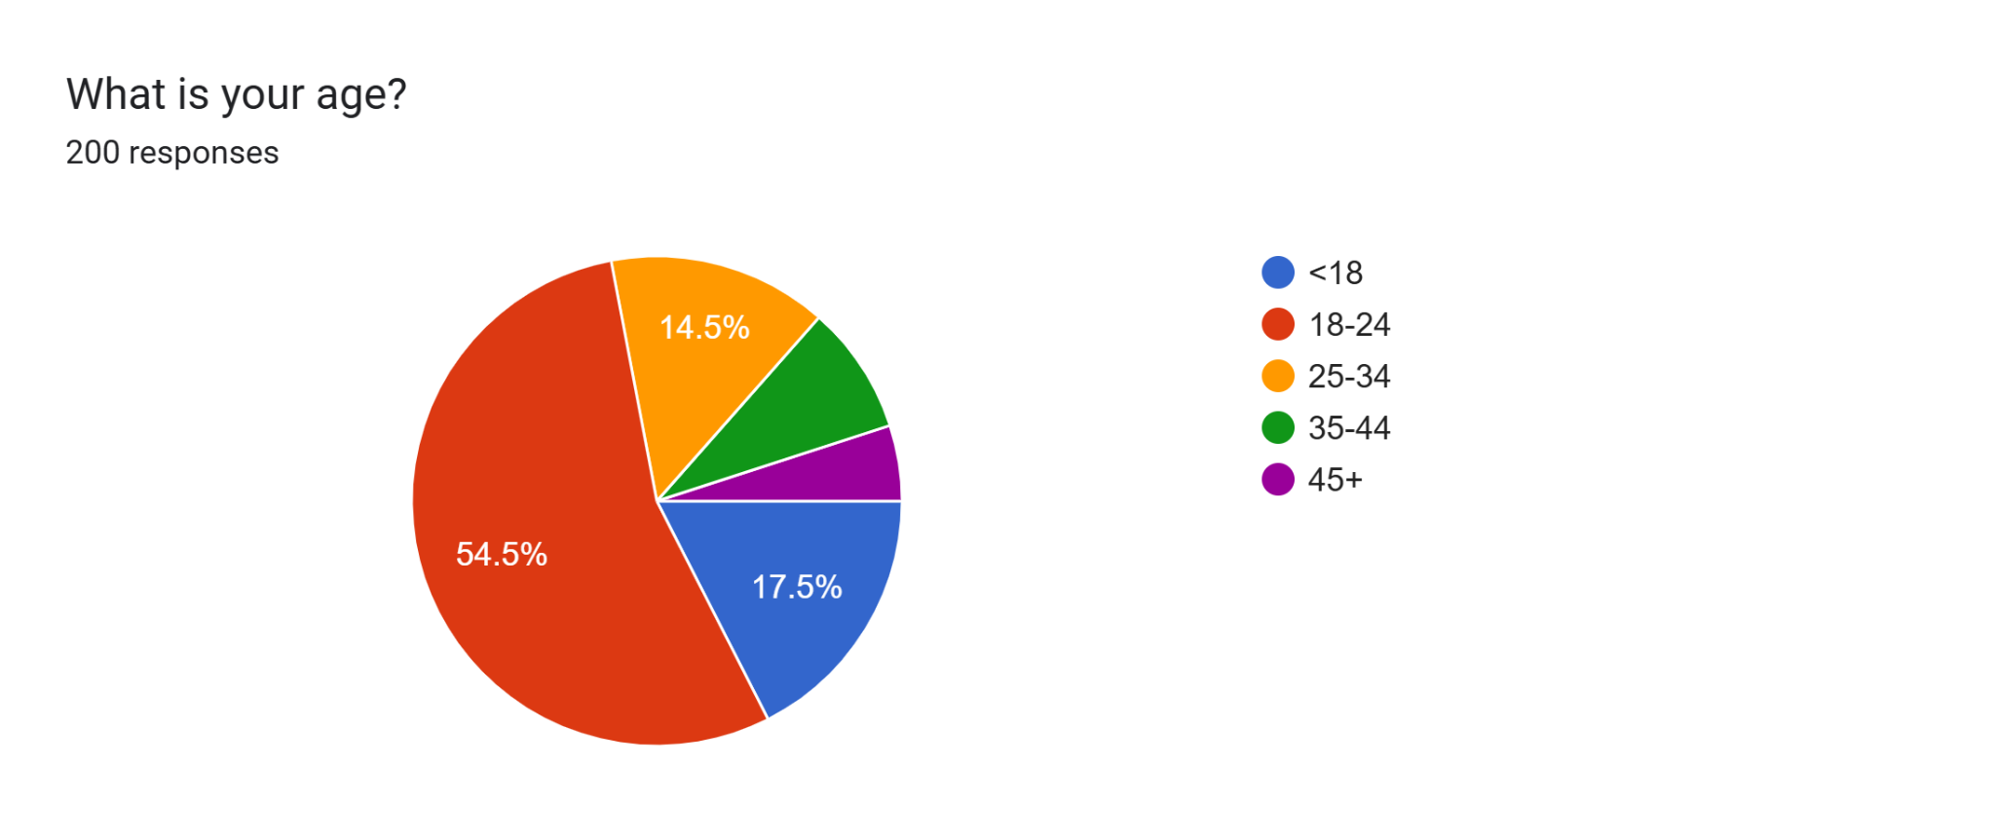

The majority of respondents fall within the **18-24 age group**, indicating a young demographic.

## How do you identify as?

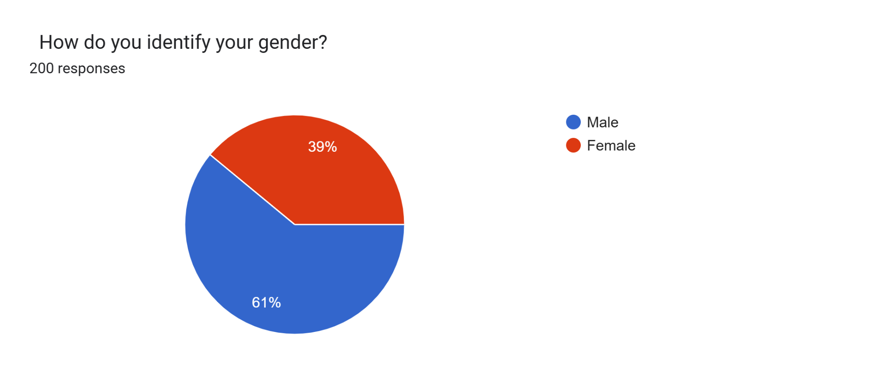

Male respondents make up 61%, with female respondents accounting for 39%.

## What is your yearly household income?

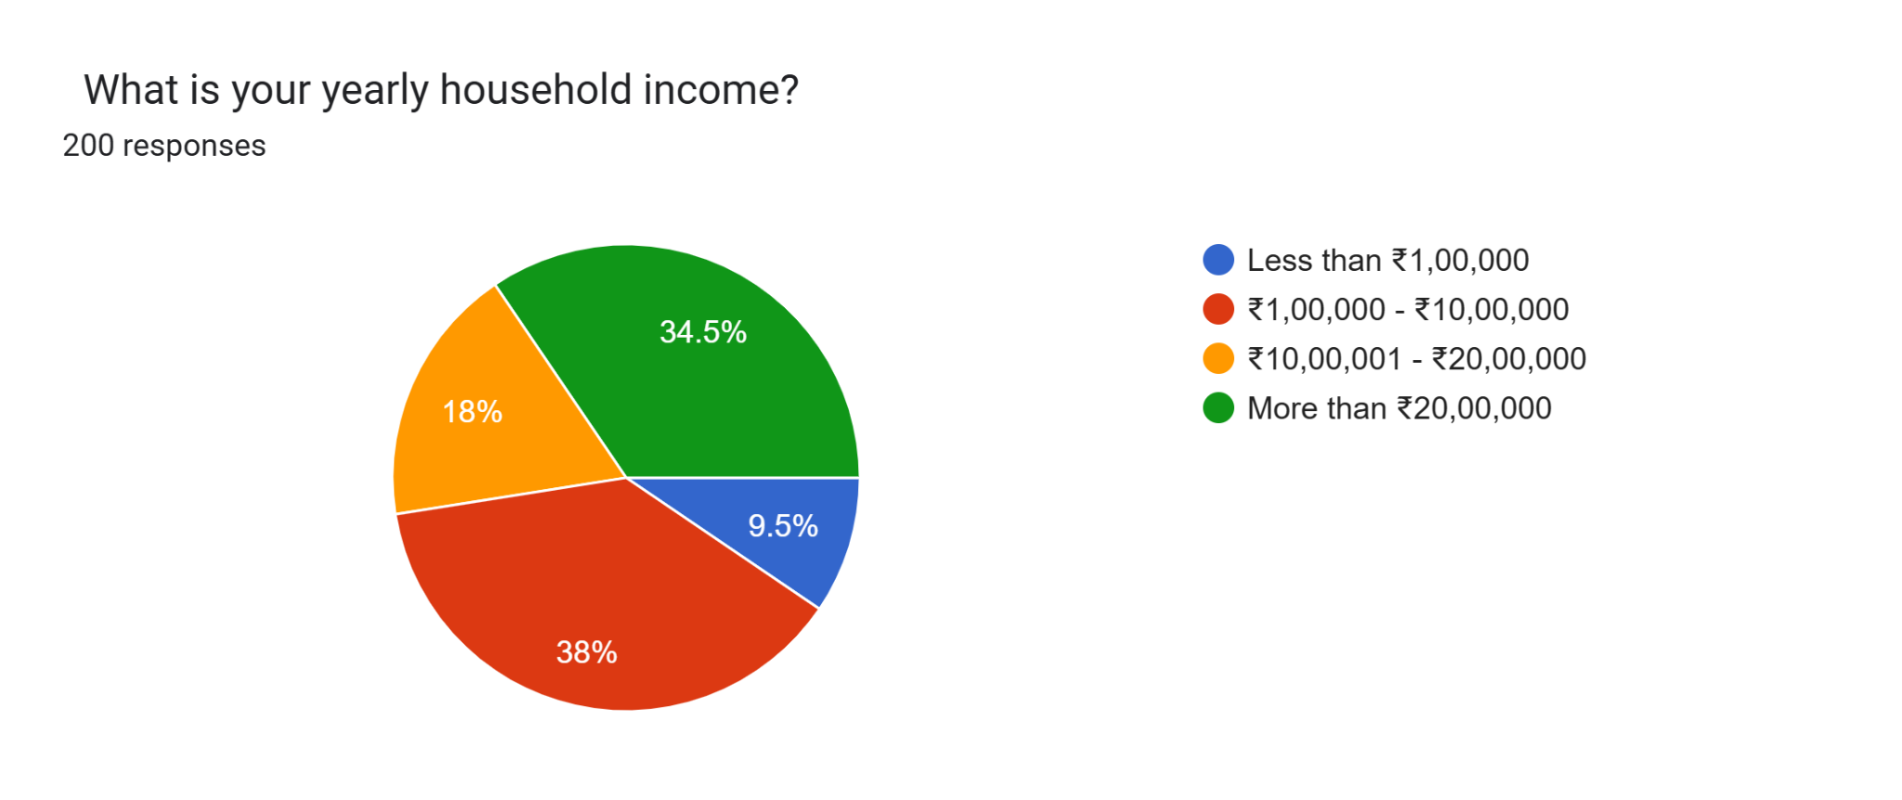

Most respondents report a yearly household **income above ₹10,00,000**, suggesting a predominantly middle-to-upper-income group.

## How often do you encounter advertisements across platforms?

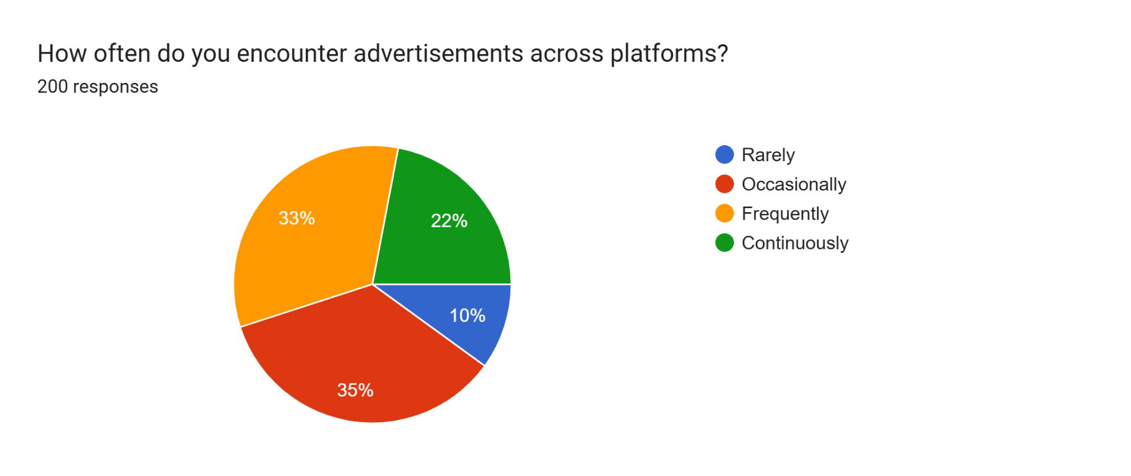

Many respondents encounter advertisements **occasionally-frequently,** highlighting high ad exposure across platforms.

## Which platform do you mostly see advertisements on?

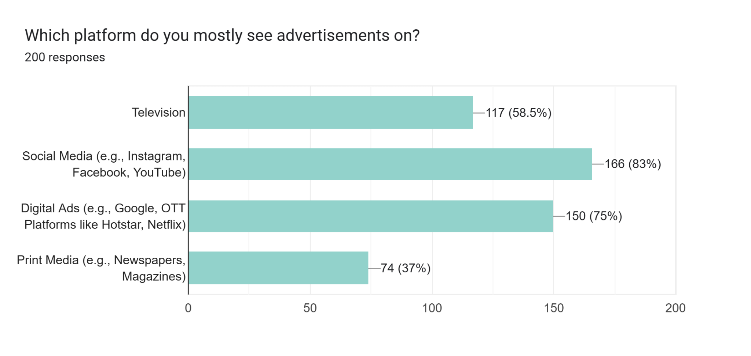

**Social media** is the leading platform where respondents encounter ads, reflecting the influence of digital media.

## Which advertising platform do you find more effective?

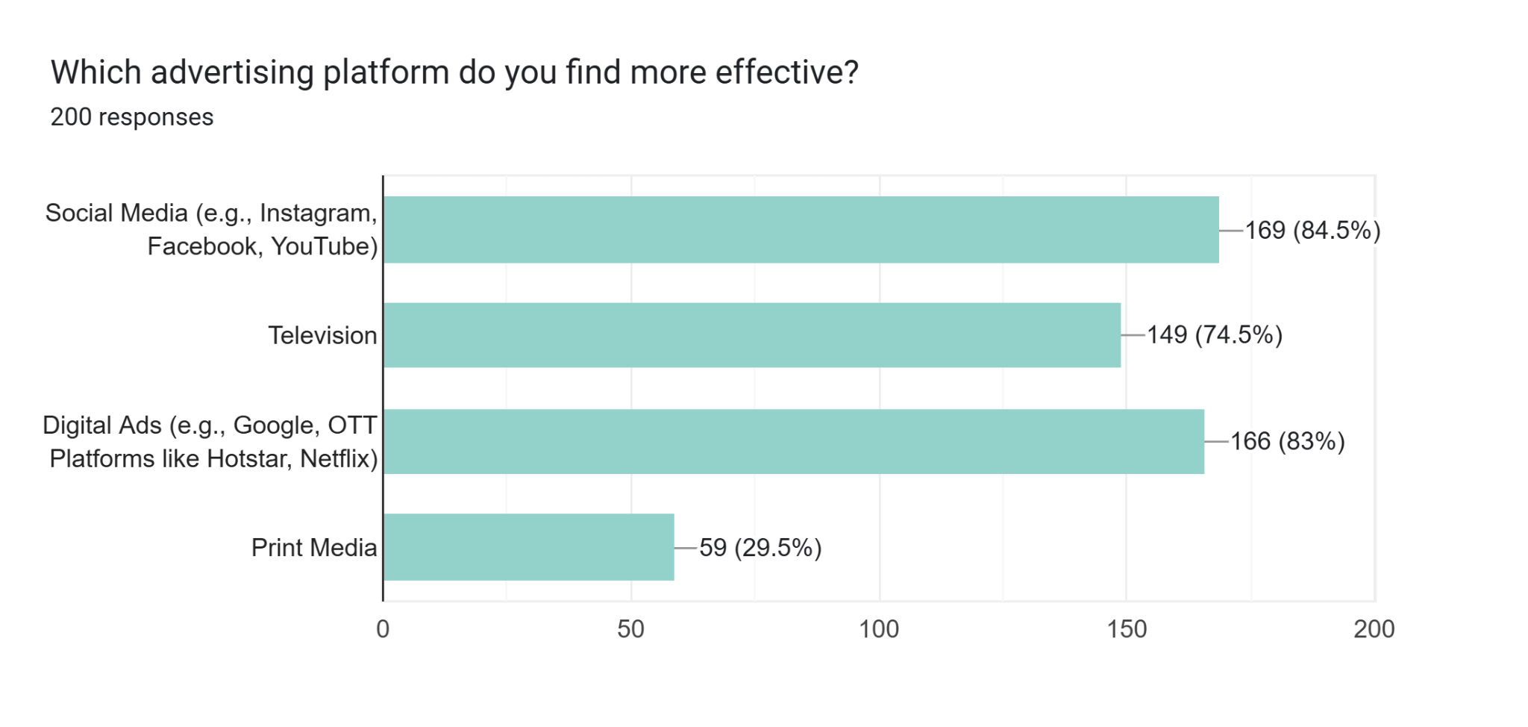

**Social media** is seen as the most effective advertising medium, likely due to its high engagement and reach.

## What is your general feeling toward advertisement?

(1-Positive, 2-Neutral,3-Negative,4-Annoyed)

Forms response chart. Question title: What is your general feeling towards advertisements?


1-Positive
2-Neutral
3-Negative
4-Annoyed. Number of responses: 200 responses.

Opinions vary, with some respondents acknowledging emotional appeals as influential, while others remain unaffected

## Do you feel that emotional appeals(eg.storytelling,emotional imagery) in ads influence your purchasing decisions?

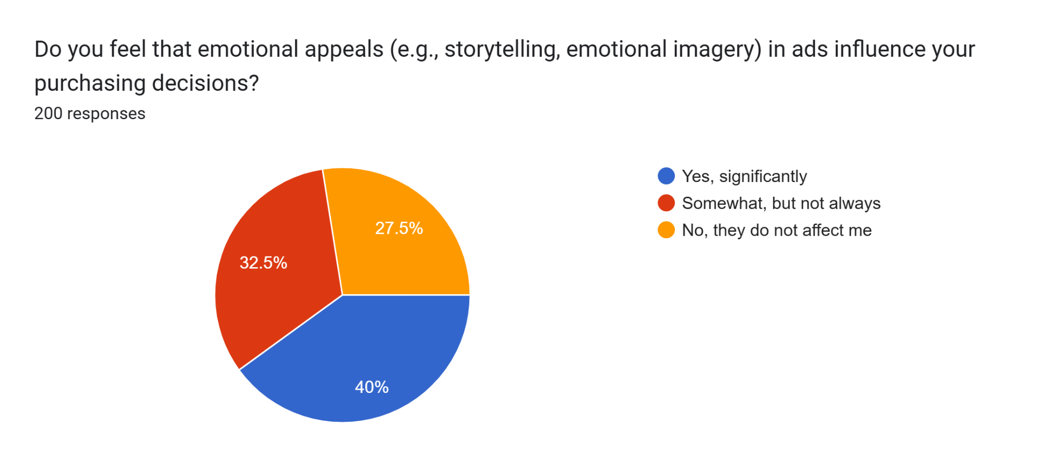

Opinions vary, with some respondents acknowledging emotional appeals as influential, while others remain unaffected.

## Have you ever made a purchase based on an advertisement featuring a celebrity or influencer?

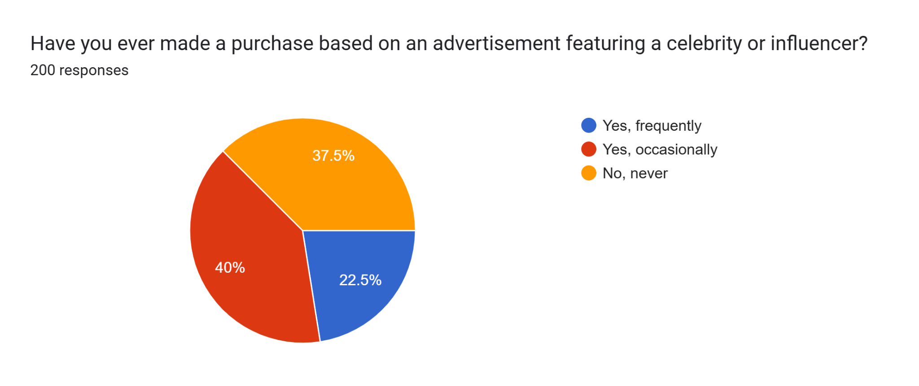

Celebrity endorsements occasionally influence purchases, though many respondents remain skeptical.

## Does your prior experience with the brand affect your perception of its advertisements?

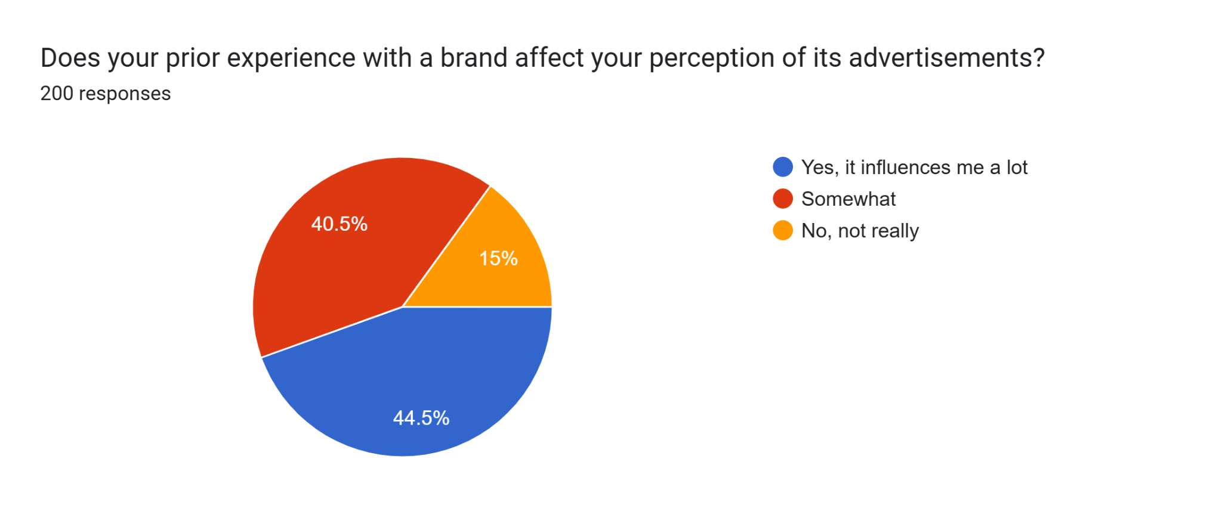

Many respondents consider previous brand experience as somewhat or highly influential in shaping ad perceptions.

## When you see a price for a product, do you tend to use that as your reference price?

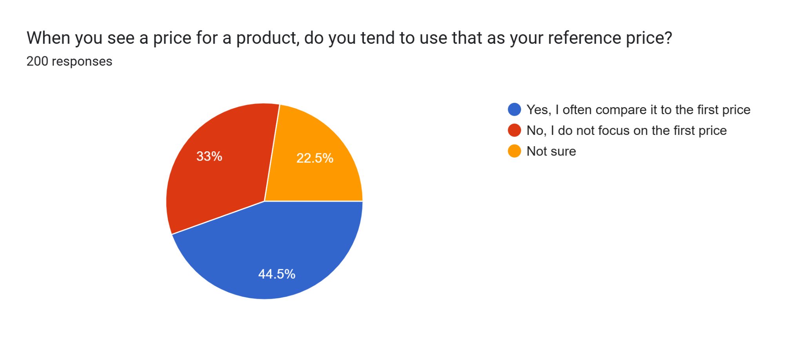

Respondents are **mixed on using advertised prices as a reference**, with a slight lean toward first price reference.

## Do you find yourself more likely to purchase a product if many others seem to be buying it?

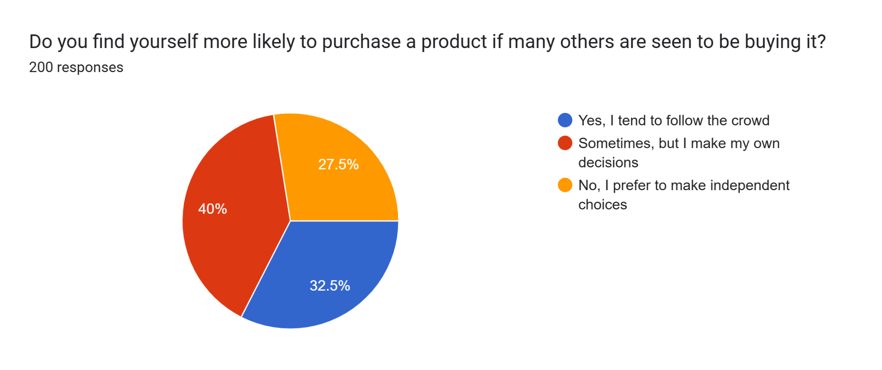

A portion of respondents is influenced by others’ purchases, while others prefer to make independent choices.

## How frequently do you make purchases after seeing an advertisement?

(1-Never 2-Rarely 3-Sometimes 4-Often)

Forms response chart. Question title: How frequently do you make purchases after seeing an advertisement?  


1-Never
2-Rarely
3-Sometimes
4-Often. Number of responses: 200 responses.

Respondents generally make purchases occasionally after seeing ads, showing moderate ad-to-purchase conversion.

## Are you concerned about misleading or exaggerated advertisements affecting your purchasing decisions?

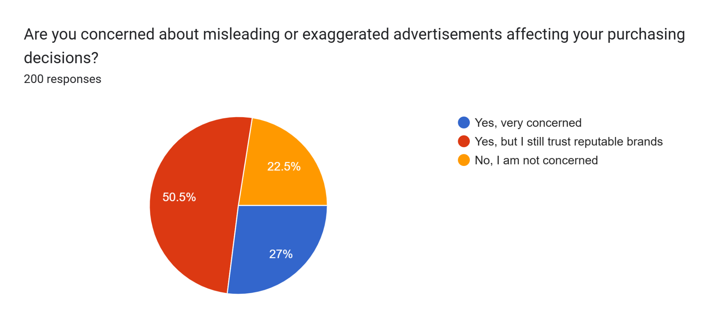

Many respondents express concern about misleading advertisements but maintain trust in reputable brands.

# KEY FINDINGS

* Emotional Appeals Influence:

40% of surveyed said emotional appeals in ads strongly influence their purchases This parallels literature suggesting that emotional appeal is the strongest motivator of consumer behavior.

* Cognitive Bias Effects:

Cognitive biases play a huge part in consumer decision-making and 44% of respondents agreed that they considered their past experiences with brands when interpreting current ads.

This indicates a clear cognitive bias at work: 44.5% reported using the first price they see to decide if their purchase is an acceptable deal (anchoring effect).

* Social Media Marketing's Influence:

Many participants indicated that they find social media advertisements to be more effective than traditional media. Indicating the increasing role of digital platforms in informing consumer choices and influencing behavior.

* Celebrity Endorsements:

Social proof is the best way to advertise, and 40% of consumers are still influenced enough by ads to buy a product that they see celebrities or other influencers using.

* Purchasing Later After Reviewing Ads Percentage:

Advertising had a moderate to strong influence, as 48.5% saying that they sometimes buy the product after viewing an advertisement and 6.5% reporting that they frequently do so.

* Demographic Insights:

Of the respondents, 54.5% were aged between 18–24 and 14.5% within the age bracket of 25–34; indicating that younger demographics engage more with advertising and are also likely to respond more effectively to marketing efforts than older demographics.

# LIMITATIONS OF STUDY

In spite of all precautions, diligence, and scrupulous intent exhibited by us to keep the study objective, there are certain limitations.

* + There is reduced diversity among groups in the sample, with certain demographic groups being underrepresented and skewing data that contribute to a distorted understanding of overall consumer behaviors.
  + One would be constrained in carrying this research study to the geographical boundaries of certain areas, thus limiting their applicability to other regions or cultures. Consumer behavior varies distinctly with regard to culture and region.
  + High income disparity limits lower-income consumers, thus curtailing their purchasing potential for the kinds and quality of products in the market, including one of low or high-end.

# CONCLUSION

In conclusion, the advertisement places a seal on changing consumer behavior toward purchasing decisions and has very far-reaching implications that can affect business, consumers, and society at large. Many researchers have investigated the advertising-consumer preference relationship through reviews of literature and empirical studies; the report attempts to shed ample light on consumer behavior, closely entwined with advertising.

In the advertising system, advertisements serve as a compelling channel for influencing consumer preferences, perceptions, and decisions. By means of persuasion, emotion appeal, and placing in certain media, advertisers tend to win consumer attraction to spur the demand of products or services.

However, the advertisers also need to keep in mind other subtle impacts of advertising on consumer purchasing decisions. Advertising is capable of both informing and detecting the consumer. However, it can also deceive, manipulate, and exploit weaknesses. The ethical concerns of truthfulness, transparency, and materialism suggest that it is important for advertising practices to become responsible and regulatory in nature.

This is what possibly limits the effectiveness of advertising in guiding consumer behavior, as it involves various other moderating factors: individual differences, cultural norms, and technological advancement. These factors must be understood in order for the advertisers to design and tailor their campaigns so as to properly incorporate the consumer characteristics and demographics so they are heard with impact.

This report explores the mechanisms, motivations, and consequences of advertising exposure. In short, despite the theoretical conceptions and practical challenges encountered in sifting through the material already presented, this report offers an accessible account of some valuable insights on that relationship.

Therefore, it will take further research and discussion in time to understand how advertising influences the beliefs and behavior of consumers. This will allow for responsible consideration of advertising considerations that involve the well-being of consumers and their societies. Greater transparency, accountability, and ethical awareness need to prevail in advertising.

**REFERENCES**

[1] U. Eka, "The Influence of Advertising on Purchasing Behavior," Adintime, 2023. [Online]. Available:[https://adintime.com/en/blog/the-influence-of-advertising-on-purchasing-behavior-n213.](https://adintime.com/en/blog/the-influence-of-advertising-on-purchasing-behavior-n213)[Accessed: 7-Nov-2024]**].**

[2] "The Effect of Advertisement on Consumer Behavior," Delesign, 2023. [Online]. Available: [https://delesign.com/blog/effect-of-advertisement-on-consumer-behavior.](https://delesign.com/blog/effect-of-advertisement-on-consumer-behavior)[Accessed: 7-Nov-2024]**].**

[3] "The Influence of Advertising on Consumer Behavior: What to Know," Agility Ads, 2023. [Online].Available[:https://www.agilityads.com/blog/the-influence-of-advertising-on-consumer-behavior-what-to-know.](https://www.agilityads.com/blog/the-influence-of-advertising-on-consumer-behavior-what-to-know)[Accessed: 7-Nov-2024]**].**

[4] S. H. Gani, "Influence of advertisement on consumers’ buying behavior: A case study of FMCG products," World Journal of Advanced Research and Reviews, vol. 22, no. 2, pp. 763–777, 2024. [Online]. Available: [https://doi.org/10.30574/wjarr.2024.22.2.1431.](https://doi.org/10.30574/wjarr.2024.22.2.1431)[Accessed: 8-Nov-2024]

[5] A. Ghosh and P. K. Saha, "Impact of advertisement on consumer buying behavior: A study on FMCG products," Singaporean Journal of Business Economics and Management Studies, vol. 5,no.4,pp.1–12,2023.[Online].Available:[https://www.singaporeanjbem.com/pdfs/SG_VOL_5_(4)/4.pdf.](https://www.singaporeanjbem.com/pdfs/SG_VOL_5_(4)/4.pdf)[Accessed: 8-Nov-2024]**].**

# APPENDIX

